***GAME DESIGN DOCUMENT***

*Baby Escape*

By *Team Maverick*

Overview/Theme

## Idea Summary

The game is based on the poem "Baby Baby Yes Mama" poem. Where the kid wants to eat sugar, so he must get it by dodging his mom through the maze type levels. The levels consist of rooms and each room has obstacles and angry mom trying to find/catch the kid. We can add more people (like angry father/grandmother) and animals (like dogs, etc.) which will help in increasing the difficulty level of the game as it progresses. We can also add some powers/special abilities (like; the kid can throw a bone towards the room where there is a dog, and a wool ball where there is a cat, in order to distract them) that may help the kid camouflage to get past the obstacles/enemies.

## Goal

**What's the aim of the player playing this game? Why will it be fun, entertaining or satisfying?**

The simplicity and progressive difficulty would make it a great game. It would be addictive as it would get harder after each passing level that would urge players to do better. Moreover, it would psychologically help people in increasing their reaction time and be a source of nostalgia for the people who are playing the game as it will remind them of their childhood memories (i.e., poem that they used to hear from their parents/grandparents).

# Mock Ups

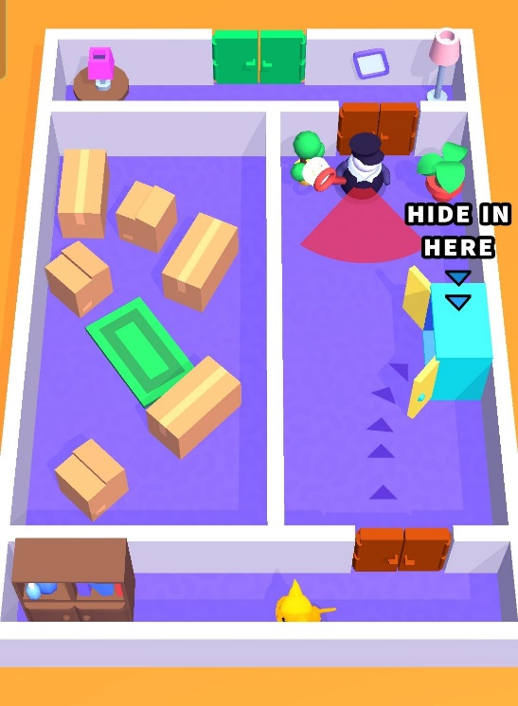

# References

* [Cat Escape](https://play.google.com/store/apps/details?id=gg.sunday.catescape&hl=en&gl=US)
* [Hide ‘N Seek](https://play.google.com/store/apps/details?id=com.seenax.HideAndSeek&hl=en&gl=US)

# Art Style (check any number of boxes that apply)

* 2D
* 3D
* Pixel
* Cartoon
* Cell Art
* Low Poly
* High Poly
* Photo Realism
* Stylized Realism
* Isometric
* Other

## Sample images or references

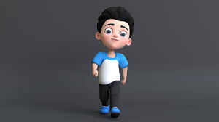

# Look & Feel / Camera

* First Person
* Third Person
* Over The Shoulder
* Top Down
* Face On
* Other

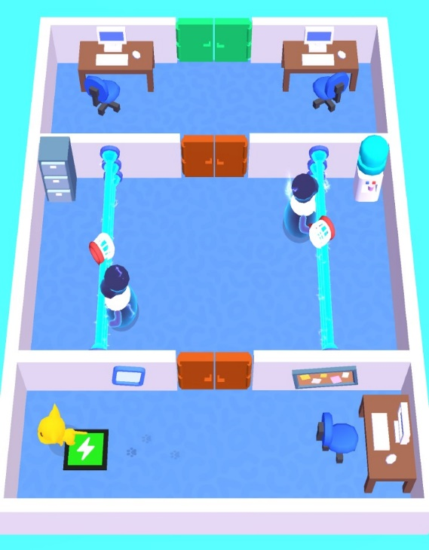

# Mechanic

## **Controls**

* Portrait
* Landscape
* Single Touch
* Joystick
* Tap
* Slide
* Swipe
* Hold
* Release
* Drag
* Other

The player movement will be controlled by dragging a invisible joystick on the bottom center of the screen and special powers gained over time can be triggered by tapping on the icon on bottom left.

## **Core Loop**

Press Play button to start…

Player drags on the bottom center of the screen to move the character

Player has to move the character through different

rooms to fetch the jar of sugar, while trying to dodge his angry mom.

In order to complete the level successfully, after finding the jar he also must exit the level through the final door.

# Progression

* Level Based
* Score Based
* Upgrade Based
* Star Based
* % Complete Based
* Engagement Based
* Content Based
* Other

**Briefly describe how the progression in the game works?**

The game will progress in levels, to complete a level it is necessary for character to collect the main sugar jar and use his bone/wool ball throwing ability to dodge aggressive enemies like cats, dogs, etc. After completing one level stars will be provided based on how many lives (out of 3) was the player able to retain. If the 3 lives were retained, 3 stars will be awarded, if player was caught once and had to restart than 2 stars and if player was caught 2 times 1 star would be awarded. No stars would be awarded if player fails to get the sugar jar, this will result in not passing the level. The total number of stars would be considered as the score and for example, if in level-15, 30 stars are required to unlock it and the player has 25, it would require the player to go back to prior levels, think of the best paths and earn more stars than their previous attempts to reach 30 stars and then unlock level 15.